**EXCEL SPREADSHEET ASSIGNMENT-2**

QUES-1. what does the dollar($) sign do in excel?

ANS-1. In Excel, a dollar sign can **denote a currency format**, but it has another common use: indicating absolute cell references in formulas.

QUES-2. How to Change the Reference from Relative to Absolute (or Mixed)?

ANS-2. **Switch between relative, absolute, and mixed references**

1. Select the cell that contains the formula.

2.In the formula bar. , select the reference that you want to change.

3.Press F4 to switch between the reference types.

QUES-3. Explain the order of operations in excel?

ANS-3. When evaluating a formula, Excel follows a standard math protocol called "order of operations". In general, Excel's order of operation follows the acronym PEMDAS (**Parentheses, Exponents, Multiplication, Division, Addition, Subtraction**) but with some customization to handle the formula syntax in a spreadsheet.

QUES-4. What, according to you, are the top 5 functions in excel and write a basic syntax

for any of two?

ANS-4. The top 5 functions in excel are:

* The SUM Function. The sum function is the most used function when it comes to computing data on Excel. ...
* The TEXT Function. ...
* The VLOOKUP Function. ...
* The AVERAGE Function. ...
* The CONCATENATE Function.

**1. SUM**

The [SUM function](https://corporatefinanceinstitute.com/resources/excel/functions/sum-function/) is the first must-know formula in Excel. It usually aggregates values from a selection of columns or rows from your selected range.

**=SUM(*number1*, [number2], …)**

Example:

**=SUM(B2:G2)** – A simple selection that sums the values of a row.

**=SUM(A2:A8)** – A simple selection that sums the values of a column.

**=SUM(A2:A7, A9, A12:A15)** – A sophisticated collection that sums values from range A2 to A7, skips A8, adds A9, jumps A10 and A11, then finally adds from A12 to A15.

**=SUM(A2:A8)/20** – Shows you can also turn your function into a formula.

[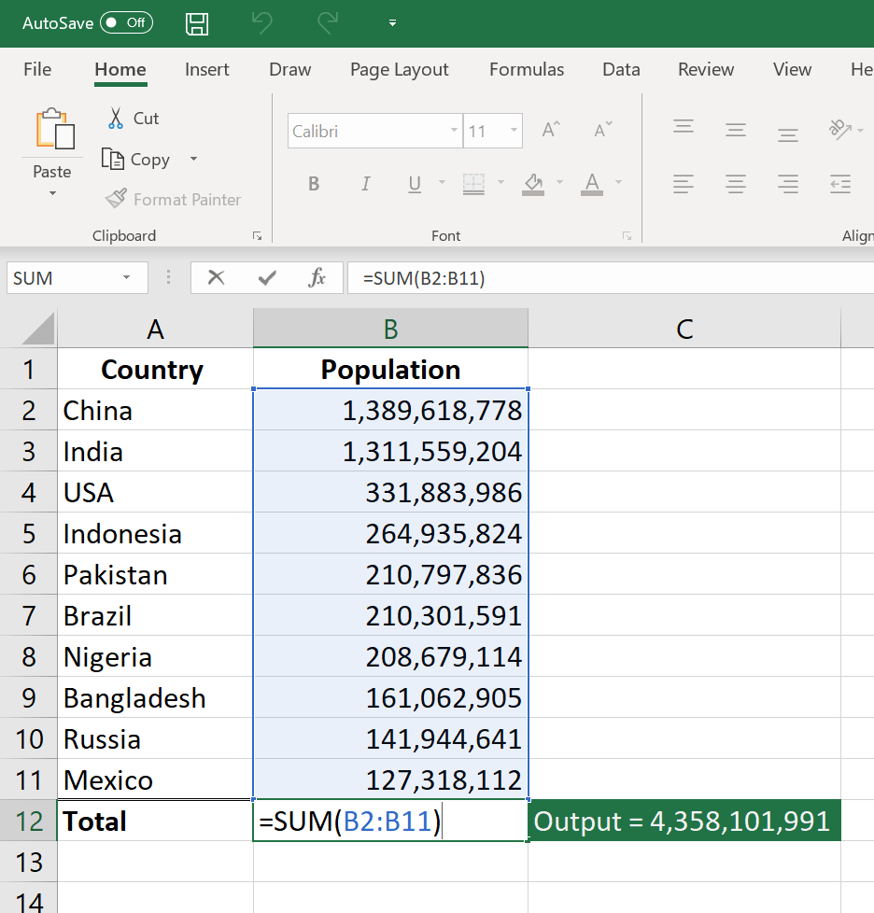](https://corporatefinanceinstitute.com/course/excel-fundamentals-formulas-for-finance)

**2. AVERAGE**

The [AVERAGE function](https://corporatefinanceinstitute.com/resources/excel/functions/average-excel-function/) should remind you of simple averages of data such as the average number of shareholders in a given shareholding pool.

**=AVERAGE(*number1*, [number2], …)**

Example:

**=AVERAGE(B2:B11)** – Shows a simple average, also similar to (SUM(B2:B11)/10)

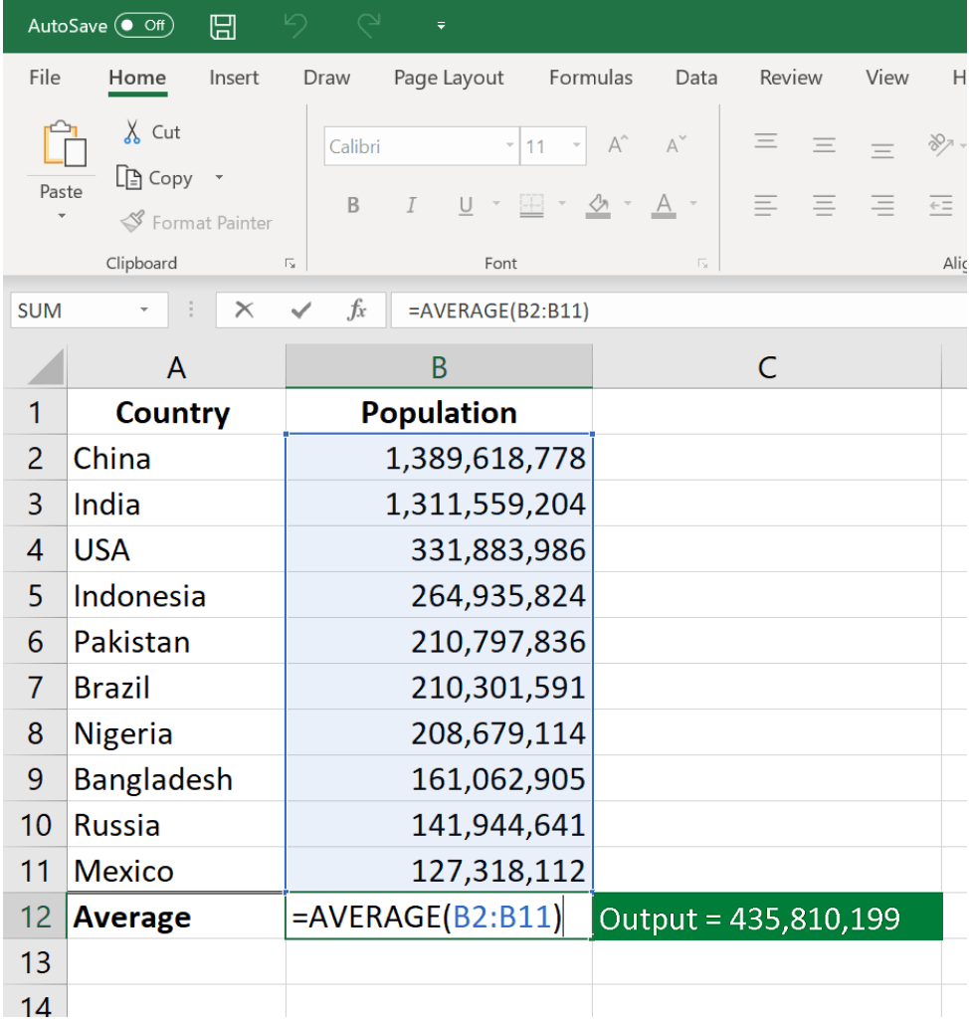

**QUES-** **5. When would you use the subtotal function?**

ANS-5. The SUBTOTAL function is used **when you display a Total row in an Excel Table**. Excel inserts the SUBTOTAL function automatically, and you can use a drop-down menu to switch behavior and show max, min, average, etc.

QUES-6. What is the syntax of the Vlookup function?

ANS-6.VLOOKUP stands for 'Vertical Lookup'. It is a function that makes Excel search for a certain value in a column (the so called 'table array'), in order to return a value from a different column in the same row.

VLOOKUP stands for 'Vertical Lookup'. It is a function that makes Excel search for a certain value in a column (the so called 'table array'), in order to return a value from a different column in the same row.